**RESOURCE GUIDE FOR FINANCIAL LITERACY/FINANCIAL SECURITY RESOURCES IN NEW YORK CITY**

**Career Development and Job Training**

* CUNY EDGE, partnering with Human Resources Administration (HRA) to provide assistance and supplemental resources to eligible students pursuing an undergraduate degree, www1.cuny.edu/sites/cunyedge
* HRA Job and Service Center locations, <https://www1.nyc.gov/site/hra/locations/job-locations-and-service-centers.page>
* HRS Career Services, offers Cash Assistance client opportunities to help them increase their job skills and hopefully build a career, leading to greater financial security; includes Workforce1 Career Centers and CareerCompass, YouthPathways, and CareerAdvance; job matching, training opportunities, and internships are available, go to <https://www1.nyc.gov/site/hra/help/employment-services.page> and <https://access.nyc.gov/programs/workforce-1>
* NYCHousing Authority Resident Economic Empowerment and Sustainability (REES), helps NYCHA residents improve their financial futures by connecting them with programs that help with education, job training, financial literacy, and starting a business; go to <https://access.nyc.org/programs/nycha-resident-economic-empowerment-and-sustainability> or call the hotline at 718-289-8100
* Support Through Employment Program (STEP) for noncustodial parents looking for work, <https://access.nyc.gov/programs/chid-support-enforcement/>
* WeCARE (Wellness, Comprehensive Assessment, Rehabilitation and Employment Program), addresses the needs of Cash Assistance clients with medical and/or mental health barriers to employment by providing individualized assistance and services; available by referral only

**Child Care Assistance and Additional Family Support**

* Child care for babies and toddlers, EarlyLearn NYC Child Care, <https://access.nyc.gov/programs/earlylearn-child-care>/
* Head Start for 3 & 4 year olds, <https://access.nyc.gov/programs/earlylearn-child-care>/

**Child Support**

* Office of Child Support Services (OCSS), financial support for children and employment support for mothers and fathers, helps troubleshoot child support issues and get parents connected with help, even if they can’t afford to pay child support right now

**Debt/Credit Counseling**

* NYC network of Financial Empowerment Centers (see Appendix A)

**Department of Social Services**

* <https://www1.nyc.gov/site/dss/index.page> for links to locations and programs, including Cash Assistance, Medicaid, SNAP, and others; also connects with ACCESS HRA for additional info and screening for benefits, especially for pregnant women or moms with a new baby

**Financial Education and Financial Coaching**

* Financial Clinic Open Coaching Sites (serve all comers)
  + Department of Consumer Affairs Licensing Center, 42 Broadway, 1st floor, New York, NY 10004
  + Make the Road NY, 92-10 Roosevelt Ave., Jackson Heights, NY 11373
  + Catholic Charities Homebase in Jamaica, Queens, 161-10 Jamaica Ave., 5th floor, Jamaica, NY 11432
* NYC network of Financial Empowerment Centers (see Appendix A)

**Financial Services (Banking, Savings)**

* NYC SafeStart Account: savings account for all New Yorkers; features no overdraft fees, no monthly fees provided that minimum balances are met ($25 or less), ATM card (no debit card), on.nyc.gov/idnycbanks
* IDNYC, free ID card for all NYC residents, <https://www1.nyc.gov/site/idnyc/index.page>; can be used to open up an account at participating banks and credit unions; check link for those institutions

**Food Banks**

* Emergency Food Assistance Program (EFAP); quickly find food pantries (for groceries you can cook at home) and community kitchens (for hot meals) that provide free food, call 311 or 866-888-8777 or <https://maps.nyc.gov/foodhelp> 212-566-7855
* Food Bank for NYC hotline,
* FoodHelp.nyc locator
* Hunger Hotline, 866-692-3663 or 866-888-8777
* School breakfast, lunch, and after-school meals, free for all students in every NYC public school (no forms to complete, although parents may be asked to complete a family income inquiry form to help schools receive funding); summer meals are also available to anyone under 18 in summer (typically end of June to end of August)
* Supplemental Nutrition Assistance Program (SNAP) locations, <https://www1.nyc.gov/site/hra/locations/snap-locations.page>
* NYC churches and other organizations that run food pantries: Bethel AME Church, 215 Beach 77th St., Arverne, NY 11692, 718-474-7712; New Spirit II, Inc., 162-04 South Rd., Jamaica, NY 11433, 718-291-4844; Queens North Family Center, 23-40 Astoria Blvd., Astoria, NY 11102, 718-726-9790; Abraham House, 342 Willis Ave., Bronx, NY 10454, 646-431-7337; see Appendix B for fuller listing throughout all boroughs

**Housing Assistance**

* HPD Housing Ambassadors; partners with community-based providers who help people prepare and apply for Housing Connect affordable housing lotteries, <https://www1.nyc.gov/site/hpd/renters/housing-ambassadors.page>
* NYC Housing Connect (searches for affordable housing and links with other helpful resources), [www.nyc.gov/housingconnect](http://www.nyc.gov/housingconnect)
* NYC Housing Development Corporation, [www.nychdc.com](http://www.nychdc.com)
* NYC Housing Authority, includes links to Family Self-Sufficiency for Section 8 voucher holders to establish savings (when rents go up, that money is instead deposited into an escrow savings account while the client establishes education, job training, and employment goals; when goals are met, the client receives the funds), go to <https://access.nyc.gov/programs/nycha-resident-economic-empowerment-and-sustainability/>
* NYC Housing Portal (links with info and resources), <https://www1.nyc.gov/site/housingportal/index.page>
* HRA Infoline at 718-557-1399 for help with Rental Assistance Programs and avoiding eviction
* Section 8/Housing Choice Voucher Program (HCV), 718-707-7771; walk-in centers are located at 478 East Fordham Road, 2nd floor, Bronx, NY 10458 and 787 Atlantic Avenue, 2nd floor, Brooklyn, NY 11238
* Homebase; helps to develop a personalized plan to overcome an immediate housing crisis and achieve housing stability

**Immigration Assistance**

* LawHelpNY.org, <https://www.lawhelpny.org> (lists 600+ free legal service projects and organizations which can help)
* Make the Road NY, provides legal and survival services; transformative education; community organizing; and policy innovation, <https://maketheroadny.org/our-model/>
* Mayor’s Office of Immigrant Affairs (MOIA), includes City-funded ActionNYC hotline for Public Charge, 800-354-0365
* NYCitizenship, provides free legal assistance with citizenship applications and financial counseling at select NYC public libraries, in partnership with the Department of Social Services, call 311 and say, “ActionNYC” to be connected with free and safe immigration legal help, or go to <https://www1.nyc.gov/site/immigrants/help/legal-services/citizenship.page>

**Income Support/Public Benefits**

* ACCESS NYC (helps NYC residents find help with food, money, housing, work, and more; also helps determine if folks are eligible for 30+ programs, regardless of immigration status and if they are already receiving benefits or have a job); <https://accessnyc.gov>
* Cash Assistance (eligible families can receive up to 60 months of federally funded cash assistance under the Temporary Aid to Needy Families Program or TANF, go to <https://www1.nyc.gov/site/hra/locations/job-locations.page>

**Intimate Partner Violence Resources**

* NYC Family Justice Centers (FJCs) with services available in all boroughs for survivors of domestic and gender-based violence, call NYC Domestic Violence Hotline at 800-621-4673 (HOPE) or 311 or 800-810-7444 if you are hearing impaired

**Legal Aid**

* ActionNYC is for every immigrant New York and provides free, safe immigration legal help through a network of trusted community organizations and schools
* City Bar Justice Center, 212-626-7383
* Legal Hotline (helps low-income New Yorkers who can’t afford a lawyer and need help with civil legal issues, including matrimonial and family law, housing law, domestic violence, bankruptcy, deb collection, and benefits), 212-626-7383
* Monday Night Law (30-minute consultations with volunteer lawyers in consumer law, family law, employment law, landlord-tenant, and small business matters); 212-626-7373 (to make an appointment)
* LawHelpNY.org, <https://www.lawhelpny.org> (lists 600+ free legal service projects and organizations which can help)

**Taxes (Free)**

* NYC Department of Consumer Affairs (for tax prep locations and finding info on the nearest Volunteer Income Tax Assistance or VITA site or Tax Counseling for the Elderly or TCE, 800-906-9887, [www.nyc](http://www.nyc); avoid any tax preparer who promises an immediate refund, as there is a time delay in receiving it (usually about 3-4 weeks)
* Earned Income Tax Credit: tax benefit for working people and families; single and married people are eligible if they worked part- or full-time at some point during the previous year and earned less than $15,270 (2018 figures for single persons with no dependents) and up to $54,884 (for married couples with three or more dependents); some non-custodial parents may also be eligible; federal, state, and City EITC can be combined to be worth up to $8,682; this can help reduce the income tax you owe and may allow you to claim a refund and get money back
* NYC Child Care Tax Credit: tax benefit to help families pay for child care; parents and guardians who earn $30,000 or less and pay for child care for children 4 and younger may be eligible; local tax credit is worth up to $1,733; this can help reduce the income tax you owe and may allow you to claim a refund and get money back
* Other tax credits: American Opportunity Tax Credit

**Utility Assistance**

* Cooling Assistance benefit (available during summer months for eligible clients); offers up to $800 for one air conditioner or fan (includes installation costs), <https://access.nyc.gov/programs/cooling-assistance-benefit/>
* Home Energy Assistance (HEAP), helps low-income homeowners and renters pay bills for heating fuel, equipment, and repair; call 212-331-3150 for more info (also known as Heat Line)
* Utility Assistance Program (UAP), assists those who utility services are being cut off due to non-payment, theft of service, or meter tampering; referred by utility companies

**APPENDIX A**

**LISTING OF NYC FINANCIAL EMPOWERMENT CENTERS**

# Get Free Financial Counseling

**NYC Financial Empowerment Centers** provide FREE one-on-one professional, financial counseling and coaching to support your in reaching your goals. Work with our counselors to:

* Reduce your debt
* Understand your rights and responsibilities when it comes to student loans
* Strengthen your credit score
* Make saving a part of your routine
* Balance a budget
* Open a bank account
* Separate personal and business finances
* And much more

[*Book an appointment online today!*](https://a866-dcwpwb.nyc.gov/talkmoney/book-appointment) for free one-on-one financial counseling or call 311 to book an appointment.

**New!** You can [create a Financial Empowerment Portal account](https://a866-dcwpwb.nyc.gov/talkmoney/) to book and manage financial counseling appointments and much more!

Below is a map and list of all Centers. **Office hours are subject to change.**

## BRONX

**New York City Financial Empowerment Center  
At Catholic Charities HomeBase**2155 Blackrock Avenue  
Bronx, NY 10472  
**Languages**: English and Spanish  
**Site Hours:** Wednesday, 9 a.m. - 5 p.m.  
**Partner:** Phipps Neighborhoods

**New York City Financial Empowerment Center  
At Phipps Neighborhoods Center**1030 East 178th Street  
Bronx, NY 10460  
**Languages:** English and Spanish  
**Site Hours:** Monday-Tuesday, and Friday, 9 a.m. - 5 p.m.  
**Partner:** Phipps Neighborhoods

**New York City Financial Empowerment Center  
At the Phipps Neighborhoods Opportunity Center**3125 Third Avenue (at 159th Street)  
Bronx, NY 10451  
**Languages:** English and Spanish  
**Site Hours**: Monday-Tuesday, 9 a.m. - 4 p.m.; Wednesday-Friday, 9 a.m. - 5 p.m.  
**Partner:** Phipps Neighborhoods

**New York City Financial Empowerment Center  
At University Neighborhood Housing Program**2715 Bainbridge Avenue  
Bronx, NY 10458  
**Languages:** English and Spanish  
**Site Hours:** Monday-Wednesday, 9 a.m. - 6 p.m.  
**Partner:** Neighborhood Trust Financial Partners

## BROOKLYN

**New York City Financial Empowerment Center  
At Bedford Stuyvesant Restoration Corporation**1368 Fulton Street  
Brooklyn, NY 11216  
**Languages:** English, Spanish, and Yoruba  
**Site Hours:** Monday-Wednesday, Friday, 10 a.m. - 6 p.m.; Thursday, 12 p.m. - 5 p.m.  
**Partner:** Bedford Stuyvesant Restoration Corporation

**New York City Financial Empowerment Center  
At Bedford Stuyvesant Restoration Corporation**630 Flushing Avenue, 2nd Floor  
Brooklyn, NY 11206  
**Languages:** English and Spanish  
**Site Hours:** Thursday, 10 a.m. - 6 p.m.  
**Partner:** Bedford Stuyvesant Restoration Corporation

**New York City Financial Empowerment Center  
At CAMBA**2244 Church Avenue, 4th Floor  
Brooklyn, NY 11226  
**Languages:** English and Spanish  
**Site Hours:** Monday-Thursday, 9 a.m. - 6 p.m.  
**Partner:** Neighborhood Trust Financial Partners

**New York City Financial Empowerment Center  
At Gregory Jackson Center for Brownsville**519 Rockaway Avenue  
Brooklyn, NY 11212  
**Languages:** English and Spanish  
**Site Hours:** Tuesday, 10 a.m. - 5 p.m.; Thursday, 12 p.m. - 5 p.m.  
**Partner:** Bedford Stuyvesant Restoration Corporation

## MANHATTAN

**New York City Financial Empowerment Center  
At the Department of Consumer Affairs Licensing Center**42 Broadway, Lobby  
New York, NY 10004  
**Languages:** English  
**Site Hours:** Monday, Thursday, and Friday, 9 a.m. - 5 p.m.  
**Partner:** The Financial Clinic

**New York City Financial Empowerment Center  
At Lower East Side People's Federal Credit Union (LESPFCU)**37 Avenue B (corner of East 3rd Street)  
New York, NY 10009  
**Languages:** English and Spanish  
**Site Hours:** Thursday, 10 a.m. - 7 p.m.; Friday, 9 a.m. - 1 p.m.  
**Partner:** Neighborhood Trust Financial Partners

**New York City Financial Empowerment Center  
At Lower East Side People's Federal Credit Union (LESPFCU) – East Harlem Branch**237 East 104th Street  
New York, NY 10029  
**Languages:** English and Spanish  
**Site Hours:** Monday-Tuesday, 9 a.m. - 4 p.m.  
**Partner:** Neighborhood Trust Financial Partners

**New York City Financial Empowerment Center  
At Manhattan Legal Services**1 West 125th Street, 2nd Floor   
New York, NY 10027  
**Languages:** English and Spanish  
**Site Hours:** Monday-Thursday, 9 a.m. - 6 p.m.  
**Partner:** Neighborhood Trust Financial Partners

**New York City Financial Empowerment Center  
At Midtown Community Court (MCC)**314 West 54th Street (between 8th and 9th avenues)  
New York, NY 10019  
**Languages:** English and Spanish  
**Site Hours:** Wednesday and Thursday, 9 a.m. - 6 p.m.; Friday, 9 a.m. – 1 p.m.   
**Partner:** Neighborhood Trust Financial Partners

**New York City Financial Empowerment Center  
At Neighborhood Housing Services of New York City**307 West 36th Street, 12th Floor (at 8th Ave)  
New York, NY 10018  
**Languages:** English and Spanish  
**Site Hours:** Monday to Thursday, 9 a.m. - 6 p.m.; Friday, 9 a.m. - 1 p.m.  
**Partner:** Neighborhood Trust Financial Partners

**New York City Financial Empowerment Center  
At Neighborhood Trust Financial Partners**530 West 166th Street, 4th Floor (at 166th Street)  
Entrance on 166th Street between St. Nicholas and Audubon avenues.  
New York, NY 10032  
**Languages:** English and Spanish  
**Site Hours:** Monday, Tuesday, and Thursday, 9 a.m. - 6 p.m.; Wednesday, 11 a.m. - 8 p.m.; Friday, 9 a.m. - 1 p.m.; Saturday, 10 a.m. - 2 p.m.  
**Partner:** Neighborhood Trust Financial Partners

**New York City Financial Empowerment Center  
At Northern Manhattan Improvement Corporation**45 Wadsworth Avenue (between 175th and 176th streets)  
New York, NY 10033  
**Languages:** English and Spanish  
**Site Hours:** Monday, Wednesday-Friday, 9 a.m. - 6 p.m.; Tuesday, 11 a.m. - 8 p.m.  
**Partner:** Neighborhood Trust Financial Partners

## QUEENS

**New York City Financial Empowerment Center  
At Catholic Charities HomeBase**161-10 Jamaica Avenue, 5th Floor  
Jamaica, NY 11432  
**Language:** English  
**Site Hours:** Monday-Friday, 9 a.m. - 7 p.m.  
**Partner:** The Financial Clinic

**New York City Financial Empowerment Center  
At Make the Road New York**92-10 Roosevelt Avenue  
Jackson Heights, NY 11372  
**Languages**: English and Spanish  
**Site Hours:** Monday, Tuesday, and Friday, 10 a.m. - 6 p.m.  
**Partner:** The Financial Clinic

**New York City Financial Empowerment Center  
At Queens Economic Development Corporation (QEDC) - The Entrepreneur Space**36-46 37th Street  
Long Island City, NY 11101  
**Languages:** English and Spanish  
**Site Hours:** Monday and Wednesday, 9 a.m. - 6 p.m.  
**Partner:** Neighborhood Trust Financial Partners

**New York City Financial Empowerment Center  
At Urban Upbound**10-38 41st Avenue  
Long Island City, NY 11101  
**Languages:** English and Spanish  
**Site Hours:** Monday-Wednesday, and Friday, 9 a.m. - 6 p.m.; Thursday, 11 a.m. - 7 p.m.  
**Partner:** Urban Upbound

**New York City Financial Empowerment Center  
At Urban Upbound**1907 Mott Avenue  
Far Rockaway, NY 11691  
**Languages:** English and Spanish  
**Site Hours:** Wednesday, 9 a.m. - 5 p.m.  
**Partner:** Urban Upbound

## STATEN ISLAND

**New York City Financial Empowerment Center  
At Lower East Side People's Federal Credit Union (LESPFCU) – North Shore Branch**2 St Paul’s Avenue  
Staten Island, NY 10301  
**Languages:** English and Spanish  
**Site Hours:** Tuesday-Wednesday, 9 a.m. - 4 p.m.  
**Partner:** Neighborhood Trust Financial Partners

## Additional Resources

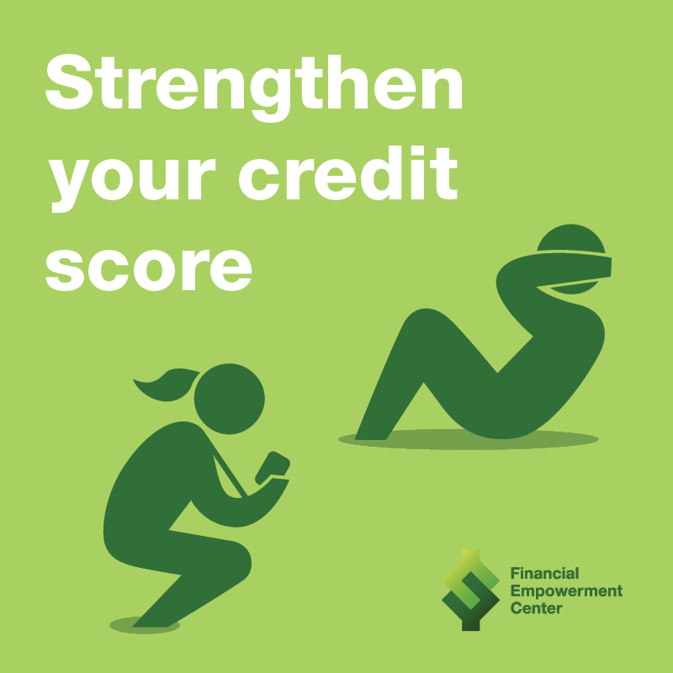

**When It Comes to Money, We Could All Use a Coach Sometimes**

In June 2018, DCA launched "When It Comes to Money, We Could All Use a Coach Sometimes" public awareness campaign to help shift the stigma associated with money and debt so people will take the steps necessary to improve their financial health just as they care for their physical health. [Learn more about the campaign](https://www1.nyc.gov/site/dca/media/When-it-comes-to-money-we-could-all-use-a-coach-sometimes.page).

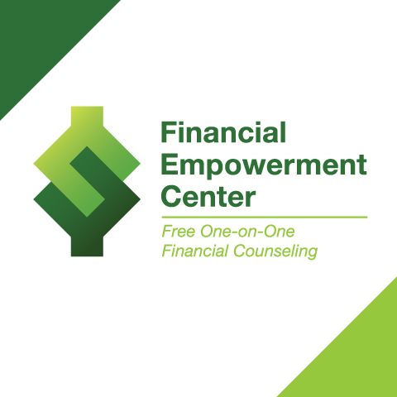

**NYC Financial Empowerment Center Brochure**

NYC Financial Empowerment Centers provide FREE one-on-one professional financial counseling and coaching to support you in reaching your goals. Financial counseling is free and confidential, regardless of income or immigration status. Download our [Financial Empowerment Center brochure](https://www1.nyc.gov/assets/dca/downloads/pdf/consumers/Financial-Empowerment-Center-Brochure-11-Languages.pdf) in 11 languages.

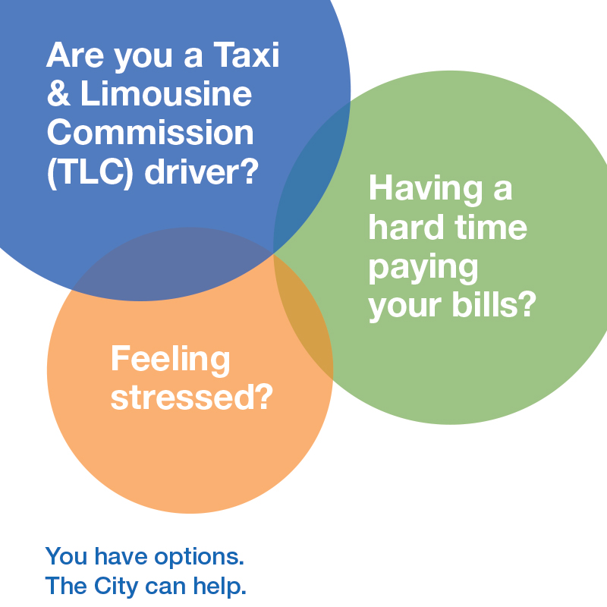

**Taxi and Limousine Drivers**

You have options if you are having a hard time paying bills and experiencing stress, depression, and anxiety, including NYC Financial Empowerment Centers, NYC Well, and ActionNYC. Download information in [English](https://www1.nyc.gov/assets/dca/downloads/pdf/businesses/TLC-Driver-Feeling-Stressed-Flyer.pdf) | [Español (Spanish)](https://www1.nyc.gov/assets/dca/downloads/pdf/businesses/TLC-Driver-Feeling-Stressed-Flyer-Spanish.pdf) | [عربي (Arabic)](https://www1.nyc.gov/assets/dca/downloads/pdf/businesses/TLC-Driver-Feeling-Stressed-Flyer-Arabic.pdf) | [বাংলা (Bengali)](https://www1.nyc.gov/assets/dca/downloads/pdf/businesses/TLC-Driver-Feeling-Stressed-Flyer-Bengali.pdf) | [中文 - 简化字 (Chinese - Simplified)](https://www1.nyc.gov/assets/dca/downloads/pdf/businesses/TLC-Driver-Feeling-Stressed-Flyer-SimplifiedChinese.pdf) | [中文 - 繁體字 (Chinese - Traditional)](https://www1.nyc.gov/assets/dca/downloads/pdf/businesses/TLC-Driver-Feeling-Stressed-Flyer-TraditionalChinese.pdf) | [Français (French)](https://www1.nyc.gov/assets/dca/downloads/pdf/businesses/TLC-Driver-Feeling-Stressed-Flyer-French.pdf) | [Kreyòl Ayisyen (Haitian Creole)](https://www1.nyc.gov/assets/dca/downloads/pdf/businesses/TLC-Driver-Feeling-Stressed-Flyer-HaitianCreole.pdf) | [한국어 (Korean)](https://www1.nyc.gov/assets/dca/downloads/pdf/businesses/TLC-Driver-Feeling-Stressed-Flyer-Korean.pdf) | [ਪੰਜਾਬੀ ਦੇ (Punjabi)](https://www1.nyc.gov/assets/dca/downloads/pdf/businesses/TLC-Driver-Feeling-Stressed-Flyer-Punjabi.pdf) | [Русский (Russian)](https://www1.nyc.gov/assets/dca/downloads/pdf/businesses/TLC-Driver-Feeling-Stressed-Flyer-Russian.pdf) | [ردو (Urdu)](https://www1.nyc.gov/assets/dca/downloads/pdf/businesses/TLC-Driver-Feeling-Stressed-Flyer-Urdu.pdf)



**The City is Here to Support Our Small Business Owners**

87% of small business owners rely on their personal credit scores to get the loans they need to grow their business. NYC Financial Empowerment Centers offer free financial counseling to help you improve your credit so you can access the resources you need. [Download flyer in English and Español/Spanish](https://www1.nyc.gov/assets/dca/downloads/pdf/businesses/FinancialEmpowermentCenter-SupportingSmallBusinesses.pdf).



**Jobs-Plus**

Jobs-Plus is a public housing-based employment program designed to increase the level of earnings and employment among residents of public housing. The program saturates targeted developments with job and career support, rent-based and other financial incentives that "make work pay," and community organizing activities that support a culture of work. Jobs-Plus aims to increase earning and employment outcomes not merely for residents who directly receive program services, but for whole public housing communities. [Learn more](http://opportunitynycha.org/workforce-development/jobs-plus/).

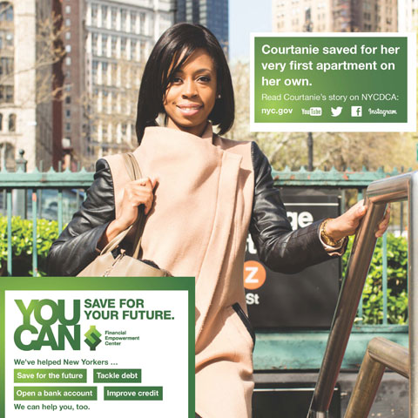

**YOU CAN…**

In June 2014, DCA launched "You Can..." public awareness campaign, featuring real New Yorkers who took control of their finances with help from the City's free Financial Empowerment Center. [Read their stories](https://www1.nyc.gov/site/dca/media/you-can2.page).

*This page was updated on 07/29/2019.*

[Directory of City Agencies](https://www1.nyc.gov/nyc-resources/agencies.page) [Contact NYC Government](https://www1.nyc.gov/home/contact-us.page) [City Employees](https://a127-ess.nyc.gov) [Notify NYC](http://www.nyc.gov/notifynyc) [CityStore](http://a856-citystore.nyc.gov/) [Stay Connected](https://www1.nyc.gov/connect/social-media.page) [NYC Mobile Apps](https://www1.nyc.gov/connect/mobile-applications.page) [Maps](https://www1.nyc.gov/nyc-resources/nyc-maps.page) [Resident Toolkit](https://www1.nyc.gov/nyc-resources/resident-toolkit.page)

NYC

Top of Form



Bottom of Form

City of New York. 2019 All Rights Reserved,

NYC is a trademark and service mark of the City of New York

[Privacy Policy.](https://www1.nyc.gov/home/privacy-policy.page) [Terms of Use.](https://www1.nyc.gov/home/terms-of-use.page)

**APPENDIX B**

**LISTING OF NYC FAITH-BASED FOOD PANTRIES**

**Benedict Avenue Community Food Pantry**  
Address is 2044 Benedict Avenue  
Bronx, NY 10462  
Call 718-518-1460

**Bread of Life Mission**  
2176 Grand Concourse  
Bronx, New York 10457  
718-839-0473

**Mid-Bronx Food Pantry**  
Address of center is 1125 Grand Concourse  
Bronx, NY 10452  
Call 718-410-6735  
Emergency boxes of groceries may be offered on a limited basis. Canned goods, perishable food items, breads, and more are distributed.

**Christ Apostolic Church WOSEM**  
Main address is 442 East 183rd Street  
Bronx, NY 10458  
Dial 516-330-1146

**Give Them To Eat**  
800 East 156th Street  
Bronx, NY 10455  
Call 718-993-8961

**Grand Concourse SDA Church, Inc.**  
1275 Grand Concourse  
Bronx, NY 10452  
Phone number is 718-681-2232

**Immaculate Conception Church**  
Address is 754 East Gun Hill Road  
Bronx, New York 10467  
Call 718-653-2200  
Volunteers and others from the church provide free food, breads, meals, and more. Some specialty items may include vouchers for groceries, clothing, or summer meals for children.

**Momentum Project Inc. @ COGOP**  
85 East 165th Street  
Bronx, NY 10452  
212-691-8100  
Runs a soup kitchen.

**Salvation Army Food Pantries and Family Stores**  
There are several around NYC and they are in all boroughs. Each has a soup kitchen for the homeless, a client choice food pantry that gives out canned or fresh groceries, clothing, and more. They also tend to give free Thanksgiving meals/turkeys, feed the low income at Christmas, and give other assistance. More on [Salvation Army in New York City](https://www.needhelppayingbills.com/html/new_york_city_salvation_army_a.html).

**Shout For Joy Baptist Church**  
253 Soundview Avenue  
Bronx, NY 10473  
Call - 347-400-0409

**Spanish Soundview SDA**  
Main address is 1822 Lacombe Avenue  
Bronx, NY 10473  
Telephone number - 718-601-1420

**St. Ann's Church of Morrisania**  
Address - 295 St. Ann's Avenue  
Bronx, NY 10454  
Main number is 718-585-5632  
Serves hot meals to the low income, needy, and homeless from the soup kitchen.

**St. Augustine Food Pantry**  
1180 Fulton Ave.  
Bronx, NY 10456  
Tel: 718-893-0072

**United Bronx Parents, Inc.**  
Location is 966 Prospect Avenue  
Bronx, NY 10459  
Contact: Christian Estrada  
Phone - 718-991-7100

**St. Peter's Episcopal Love Kitchen**  
2500 Westchester Avenue  
Bronx, New York 10461  
718-931-9270

**Transfiguration Lutheran Church**  
763 Prospect Avenue  
Bronx, NY 10455  
Dial 718-861-0224  
Volunteers and people from the parish distribute groceries, food, and meals to the low income and needy. May have Easter or Thanksgiving meal baskets.

**Way Out Church Ministries Inc.**  
518 East 148th Street  
Bronx, NY 10455  
Telephone number is 718-665-8069

**Mt. Gilead Baptist Church**  
1682 Morris Avenue  
Bronx, NY 10457  
718-294-8580

**Part of the Solution food pantry**  
2759 Webster Avenue  
Bronx, NY 10458  
718-220-4892  
Free food pantry, groceries, Easter, Thanksgiving, and Christmas meals are offered for the low income. May have vouchers for clothing and case management services too.

**River Watch Inc.**  
Main locations is 1600 Sedgewick Avenue Suite 1  
Bronx, New York 10453  
Call 646-359-9126

**Act of Faith Ministries**  
141 Manhattan Avenue  
Brooklyn, NY 11206  
Phone number 718-596-8950  
Call for hours of free food distribution services.

**Basilica of Our Lady of Perpetual Help**  
Main address is 545 60th Street  
Brooklyn, NY 11220  
Call 718-492-9200

**Bethesda Memorial Baptist Church**   
49 Cornelia Street  
Brooklyn, NY 11221  
718-455-2678  
A charity soup kitchen is offered.

**Calvary Free Will Baptist Church**  
1520-30 Herkimer Street  
Brooklyn, NY 11207  
Main number is 718-485-4923

**CCNS-Brooklyn West Family Center**  
191 Joralemon Street  
Brooklyn, NY 11201  
718-722-6001  
Provides limited emergency non-perishable food through a free food pantry.

**Church of the Holy Spirit**  
1712 45th Street  
Brooklyn, NY 11204  
Tel: 718-722-6001  
Offers food, groceries and maybe clothing to anyone in need.

**Crossover Baptist Church Community Outreach Help Center.**  
358 Kosciusko Street  
Brooklyn, NY 11221  
Tel: 718-452-4653

**Cuyler Warren United Methodist Church**  
Location 450 Warren Street  
Brooklyn, NY 11217  
Phone - 718-875-8502  
Food and clothing closet assistance for those in need of help in NYC area.

**Fort Greene Hugh Gilroy Senior Center**  
447 Kingsborough 4th Walk 2nd Floor  
Brooklyn, NY 11233  
Tel: 718-756-8400  
Groceries are distributed to families. Elderly or disabled people are eligible, and crisis situations prioritized.

**Isaiah's Temple of Mt. Hope**  
862 Glenmore Avenue  
Brooklyn, NY 11208  
Telephone - 718-850-1499  
Emergency food assistance for those in need who live in designated service areas.

**Middle Collegiate Church**  
50 East 7th Street  
New York, NY 10003  
Phone - 212-477-0666

**Kings Bay Y Senior Center**  
3643 Nostrand Avenue  
Brooklyn, New York 11229  
718-648-2053  
Food and clothing provided, including possible home delivered meals. Caregivers can be offered help as wheel. Get information about services such as Meals on Wheels, workshop and classes for seniors, and it may serve as a cooling station in the summer.

**Make the Road New York**  
Address is 301 Grove Street  
Brooklyn, NY 11237  
Call 718-418-7690  
The non-profit provides food and clothing. May also have a hot meal on Thanksgiving Day and Christmas Day.

**Mission Assembly Pentecostal**  
Location is 118 Bushwick Avenue  
Brooklyn, NY 11206  
718-649-2432

**My Brother's Keepers Those Who Care, Inc.**  
1770 Flatbush Avenue  
Brooklyn, New York 11210  
347-312-6392  
Provides a free food pantry to people in need living in service area. Assistance is provided up to once every four months or so.

**New Hope Pentecostal Church of Jesus Christ**  
1838 Park Place  
Brooklyn, NY 11233  
Main phone 646-626-1827

**Our Lady of Mercy Church**  
Location - 680 Mother Gaston Blvd  
Brooklyn, NY 11212  
Tel: 718-346-3166

**St. Augustine American Catholic Church**  
298 Schenectady Avenue  
Brooklyn, NY 11213  
Telephone number is 718-773-1338

**St. John's Bread and Life Program**  
795 Lexington Avenue  
Brooklyn, NY 11221  
Address - 718-574-0058  
Offers food boxes, holiday meals, Thanksgiving baskets, and more. The non-profit may also provide clothing vouchers to be used for needed items.

**St. Therese of Lisieux RC Church**  
Location is 4410 Avenue D  
Brooklyn, NY 11203  
Tel: 718-451-0683

**The Salvation Army Bushwick**  
1151 Bushwick Avenue  
Brooklyn, New York 11221  
Tel: 718-455-4102  
A leading social service agency offers assistance with free food and clothing. Some limited financial support may be offered. Also get referrals for medical care, dental and eye care. Additional assistance includes programs such as Angel Tree.

**The Salvation Army Sunset Park Corps**  
520 50th Street  
Brooklyn, NY 11220  
Tel: 718-438-1771

**Triumphant Full Gospel Assembly**  
889 Rutland Road  
Brooklyn, New York 11203  
Tel: 718-774-4696  
Provides an emergency food pantry for nearby Brooklyn residents with low income. May offer a few day supply of food.

**Vaad Hakol Crown Heights**   
1276 President Street  
Brooklyn, NY 11213  
Tel: 718-756-2203

**Zichron Acheinu Levy Menachem Tzion**  
928 44th Street  
Brooklyn, NY 11219  
Tel: 347-742-0552  
The pantry may have Canned Meats including Tuna, Ham, Chicken, Boxed Pastas, rice, Peanut Butter, soup, and much more.

**Queens Tabernacle Church**  
Address of food bank 114-03 Colfax Street  
Cambria Heights, NY 11411  
Dial 718-465-4448  
Runs a food pantry to those in need.

**Elmcor Youth & Adult Activities Inc.**  
107-20 Northern Blvd.  
Corona, New York 11368  
718-651-0096

**Mt. Olivet Gospel Church Food Pantry**  
33-27 97th Street  
Corona, NY 11368  
Tel: 718-478-0780

**Park Avenue Synagogue**  
50 East 87th Street  
New York, NY 10128  
Tel: 212-369-2600

**Atonement Lutheran Church**  
Main address is 30-61 87th Street  
East Elmhurst, NY 11369  
Tel: 718-639-6074  
Services include shelter, hot meals, linens, and hygiene items.

**First Presbyterian Russell Sage**  
896 Central Avenue  
Far Rockaway, NY 11691  
Call 718-337-2202 for hours and information.

**Jewish Community Council of the Rockaway Peninsula**  
Address: 1525 Central Avenue  
Far Rockaway, NY 11691  
718-327-6060

**Catholic Charity churches of New YorkCity**  
The working poor, refugees, immigrants, and others can use their social services. Centers in Queens along with Brooklyn and Manhattan as well as other parts of the city give assistance. Free emergency boxes of food, baby formula for single moms, and other groceries are given. They also help clients apply for USDA commodities, Meals on wheels, and more. Continue with [Catholic Charities assistance in NYC](https://www.needhelppayingbills.com/html/new_york_city_catholic_chariti.html).

**United Methodist Center in Far Rockaway**  
1032 Beach 19th Street  
Far Rockaway, NY 11691  
Tel: 718-327-8460  
Provides food, meals, and blankets for people whose income meets certain poverty guidelines.

**Flushing Jewish Community Council**  
4343 Bowne Street  
Flushing, NY 11355  
Tel: 718-463-0434

**Macedonia AME Church**  
37-22 Union Street  
Flushing, NY 11354  
Call the church at 718-539-0024

**Forest Hills Senior Center**  
108-25 62nd Drive  
Forest Hills, New York 11375  
718-699-1010  
The non-profit provides senior services, including lunch, games, and conversation. Get information on programs such as Medicate, and prescription assistance as well. Meals on Wheels in available from volunteers.

**Beraca SDA Church**  
Main address - 91-19 191st Street  
Hollis, NY 11423  
Tel: 718-341-9494

**Our Lady of Grace Ministry**  
Address: 158-10 101st Street  
Howard Beach, New York 11414  
Tel: 718-845-6635

**The Salvation Army - Templo de Queens**  
86-07 35th Avenue  
Jackson Heights, NY 11372  
Telephone 718-335-3693  
The social service agency provides a food pantry, clothing closet, and case management services. Self-sufficiency is available, such as employment support. Provides information and referral to community services, assistance with paperwork completion, [details on food assistance](https://www.needhelppayingbills.com/html/food_assistance_programs.html) and SNAP stamps, LIHEAP, and other government aid.

**ACQC**  
161-21 Jamaica Avenue 6th Floor  
Jamaica, NY 11433  
718-896-2500

**Blanche Memorial**  
109-74 Supthin Blvd.  
Jamaica, NY 11435  
Main number is 718-658-2458

**Holy Ghost Upper Room Filing Station Ministry Inc.**  
146-17 133rd Avenue  
Jamaica, NY 11436  
Dial 718-529-2060

**Morris Brown AME Church**  
145-03 Rockaway Blvd.  
Jamaica, New York 11436  
Call 718-598-7581

**Rush Temple A.M.E. Zion Church**  
Address - 119-48 Sutphin Blvd  
Jamaica, NY 11434  
Tel: 917-226-4947

**Theodora G. Jackson Adult Care**  
92-47 165th Street  
Jamaica, NY 11433  
Tel: 718-657-6570  
Senior programs and resources for the elderly, including an onsite food pantry. Congregate and home delivered meals may also be arranged.

**Richmond Hill SDA Community**  
114-08 Jamaica Avenue  
Richmond Hill, NY 11418  
718-301-3179  
Offers help in the form of a food pantry and clothes closet for persons who live in region.

**Salvation Army Ridgewood Citadel Corps**  
69-23 Cypress Hills Street  
Ridgewood, New York 11385  
Phone number 718-497-4356  
Various financial assistance, social services, and other resources are available for the low income.

**Black Forum of Coop City Inc.**  
177 Dreiser Loop Room# 20  
Bronx, NY 10475  
Call the food pantry at 718-320-8035

**Los Redimidos Por La Sangre De Jesus**  
Address - 609 East 182nd Street  
Bronx, NY 10457  
Tel: 718-563-7585

**Leviticus Church**   
114-12 Van Wyck Expressway  
South Ozone Park, NY 11420  
Dial 718-322-1095 for hours  
The church caters or feeds low income people in the community in the area of clothing, nutrition and food. Due to economic situations and financial conditions, the center is also accepting other persons in regards to job loss and other economic hardships.

**St. Luke's Baptist Church Food Pantry**  
133-28 232nd Street  
Springfield Gardens, NY 11413  
Tel: 718-712-5427

**Christ Is The Answer Full Gospel Ministry Inc.**  
198-17 Hollis Avenue  
St. Albans, NY 11412  
Tel: 718-749-8768

**St. Alban's Deliverance Feeding Program**  
205-14 Hollis Avenue  
St. Albans, NY 11412  
Tel: 718-468-6060  
There is an onsite food pantry for basic staples, such as breads, fruits and vegetables and frozen foods. Or call/stop by for information about applying for SNAP (Food Stamps) in New York.

**Arrochar Friendship Club**  
85 Jerome Avenue  
Staten Island, New York 10305  
Tel: 718-720-6110

**Jewish Community Center of Staten Island**  
1466 Manor Road  
Staten Island, NY 10314  
718-475-5242  
Runs a food pantry. The center may also offer free hygiene products, perishables, baby food, formula, and diapers, when available. All items are provided based on resources, donations, and availability.

**Our Lady of Good Counsel Church**  
42 Austin Place  
Staten Island, NY 10304  
718-447-1503

**Salvation Army/Port Richmond Corps Community Center**  
1295 Forest Avenue  
Staten Island, NY 10302  
Tel: 212-337-7201  
Provides emergency assistance with food, clothing, rental, electric bill payment assistance, and prescriptions as well as a soup kitchen.

**All Nations Baptist Church of Woodhaven**  
86-74 80th Street  
Woodhaven, NY 11421  
Telephone number is 718-847-4229

**Christian Cultural Center**  
1400 Linden Blvd  
Brooklyn, NY 11212  
718-272-1325  
Offers food to people of all religions and backgrounds.

**Cornerstone Baptist Food Pantry**  
562-74 Madison Street  
Brooklyn, New York 11221  
Telephone - 718-789-0946

**Haitian Evangelical Clergy**  
1488 New York Avenue  
Brooklyn, NY 11210  
Tel: 347-444-8661  
Offers food pantry and clothing assistance. Food and clothing is based on availability, limited fresh perishables and frozen food may be available as well as emergency grocery boxes. Also has culturally sensitive holiday meals.

**Mt. Calvary Baptist Church**  
Main address is 560 Rogers Avenue  
Brooklyn, New York 11225  
718-856-0356  
Provides grocery store vouchers and a food pantry which may be used to purchase fresh perishable items only.

**Newman Memorial United Methodist Church**  
257 Macon Street  
Brooklyn, NY 11216  
Tel: 718-622-7955  
Serves hot meals from soup kitchen.

**St. Cecilia's Gift of Love Food Pantry**  
23 Monitor Street  
Brooklyn, NY 11222  
Tel: 718-866-7486

**Garden of Prayer**  
1874 Washington Avenue  
Bronx, NY 10457  
Tel: 718-294-3401  
The free food bank also have free hygiene supplies. Or get cereal, spaghetti, and other international foods.

**Shout For Joy Baptist Church**  
253 Soundview Avenue  
Bronx, NY 10473  
Main telephone - 347-400-0409  
Has a free food pantry on site. Clothing closet helps with clothing for children, job interviews, women and men. Provides referrals to other non agencies in the New York City area as well.

**The House of David Church**  
747-749 Hendrix Street  
Brooklyn, NY 11207  
Call 516-301-6306

**Holy Tabernacle Church Inc.**  
3780 Third Avenue  
Bronx, NY 10456  
Tel: 347-603-7163

**Trinity's Services and Food for the Homeless Inc.**  
602 East 9th Street  
New York, NY 10009  
Main number is 212-228-5254

**Rutgers Thursday Nighters**  
236 West 73rd Street  
New York, NY 10023  
212-877-8227

**New Brighton Church of God in Christ**  
386 Jersey Street  
Staten Island, NY 10301  
Tel: 347-626-4526

**Faces NY Inc.**  
123 West 115th Street  
New York, NY 10026  
212-663-7772

**Good Shepherd Food Pantry**  
Location - 104 Cooper Street  
New York, New York 10034  
212-567-1300  
Provides non-perishable food items once a month to the low income and working poor. Families must first qualify through the social service office to receive support.

**Father Creavins Food Pantry**  
276 West 151st Street  
New York, NY 10039  
Tel: 212-690-7555

**Church of the Epiphany**  
1393 York Avenue  
New York, NY 10021  
Dial 212-737-2720

**Holy Apostles Soup Kitchen**  
296 9th Avenue  
New York, NY 10001  
Main phone number is 212-807-6799  
Serves hot meals, lunches, and more.

**New York City Rescue Mission**  
90 Lafayette Street  
New York, NY 10013  
Tel: 212-226-6214  
Runs a food pantry and clothing closet, with a focus on the homeless. Other services include shelter, job training, information on public assistance and more.

**Part of the Solution**  
Address - 2759 Webster Avenue  
Bronx, New York 10458  
Main phone number is 718-220-4892  
Administers a food pantry and clothing for adults and children.

**Jackson Heights SDA**  
72-25 Woodside Avenue  
Woodside, New York 11377  
Tel: 718-424-4544  
Basic staples, fruits and vegetables and frozen foods are offered from the food bank. Get information about applying for public assistance such as Medicaid, SNAP (Food Stamps) and more is also available.

The list above is only a sampling of free food pantries and centers. For additional locations of non-profit food banks in the New York City area, dial 212.566.7855.